COMSATS University Islamabad
Attock Campus
Final Lab Project Report


Course Details
Field | Details
Course | SCAD (Software Construction & Development)
Lab Instructor | Mam Maryam Bukhari
Semester | Lab Project (Terminal)

Submitted By
Registration No | Name
FA23-BSE-026 | Ubaid Hassan
FA23-BSE-048 | Mesum Abbas

Project Title
AgroVision AI — Plant Disease Detector
Using Convolutional Neural Networks with PyTorch

Software Construction & Development (SCAD) — Lab Terminal Project
Spring 2026

Table of Contents
1. Project Description
2. Advantages & Key Strengths
3. Code & Output Screenshots
4. Limitations
5. Future Work
6. Changes We Made
7. References & Links

1. Project Description
AgroVision AI - Plant Disease Detection System is a full-stack AI-based web application developed to identify diseases in plant leaves using deep learning. The application uses a Convolutional Neural Network (CNN) model trained on multiple plant disease categories to predict diseases from user-uploaded leaf images.
1.1 How It Works

Preprocesses the image (resize to 224×224, convert to tensor)
Runs it through a trained CNN model
Returns the predicted disease name, description, prevention steps, and recommended supplements
1.2 Model Architecture
Component | Details
Framework | PyTorch 1.8.1
Type | Custom CNN (4 convolutional blocks + 2 fully-connected layers)
Input | RGB image resized to 224 × 224 pixels
Output | Logits vector of size 39 (argmax gives predicted class index)
Training Dataset | PlantVillage dataset
1.3 Technology Stack
Technology | Purpose
Python 3.8 | Primary programming language
PyTorch 1.8.1 | Deep learning framework (CNN model)
Flask 1.1.2 | Web framework (backend)
Pillow | Image processing (resize, format conversion)
Pandas | CSV data handling (disease + supplement info)
Postman | API testing
Trello | Project management & task tracking
Hugging Face Spaces | Free hosting & deployment

2. Advantages & Key Strengths
- AI-Based Plant Disease Detection: The application can identify multiple plant diseases from uploaded leaf images using a trained CNN deep learning model.
- Lightweight & CPU Friendly: The model is optimized to run without GPU support, making it suitable for free cloud hosting platforms like Hugging Face Spaces.
- Multithreading Implementation: Python threading is used for background model loading and prediction handling, improving responsiveness.
- REST API Support: The project includes API endpoints tested using Postman for backend validation.
- User-Friendly Web Interface: The Flask web application allows users to upload plant images easily and receive disease predictions.
- Robust Error Handling: The application handles invalid uploads, missing files, and runtime errors properly.
- Unit Testing Integration: Testing functions are implemented using Python's unittest framework.
- Easy Deployment & Open-Source: The project is based on an existing open-source repository with additional modifications.

3. Code & Output Screenshots
3.1 User Interface Screenshots


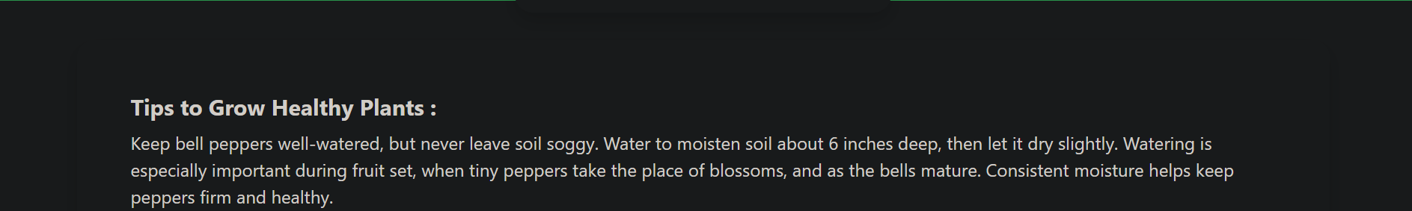

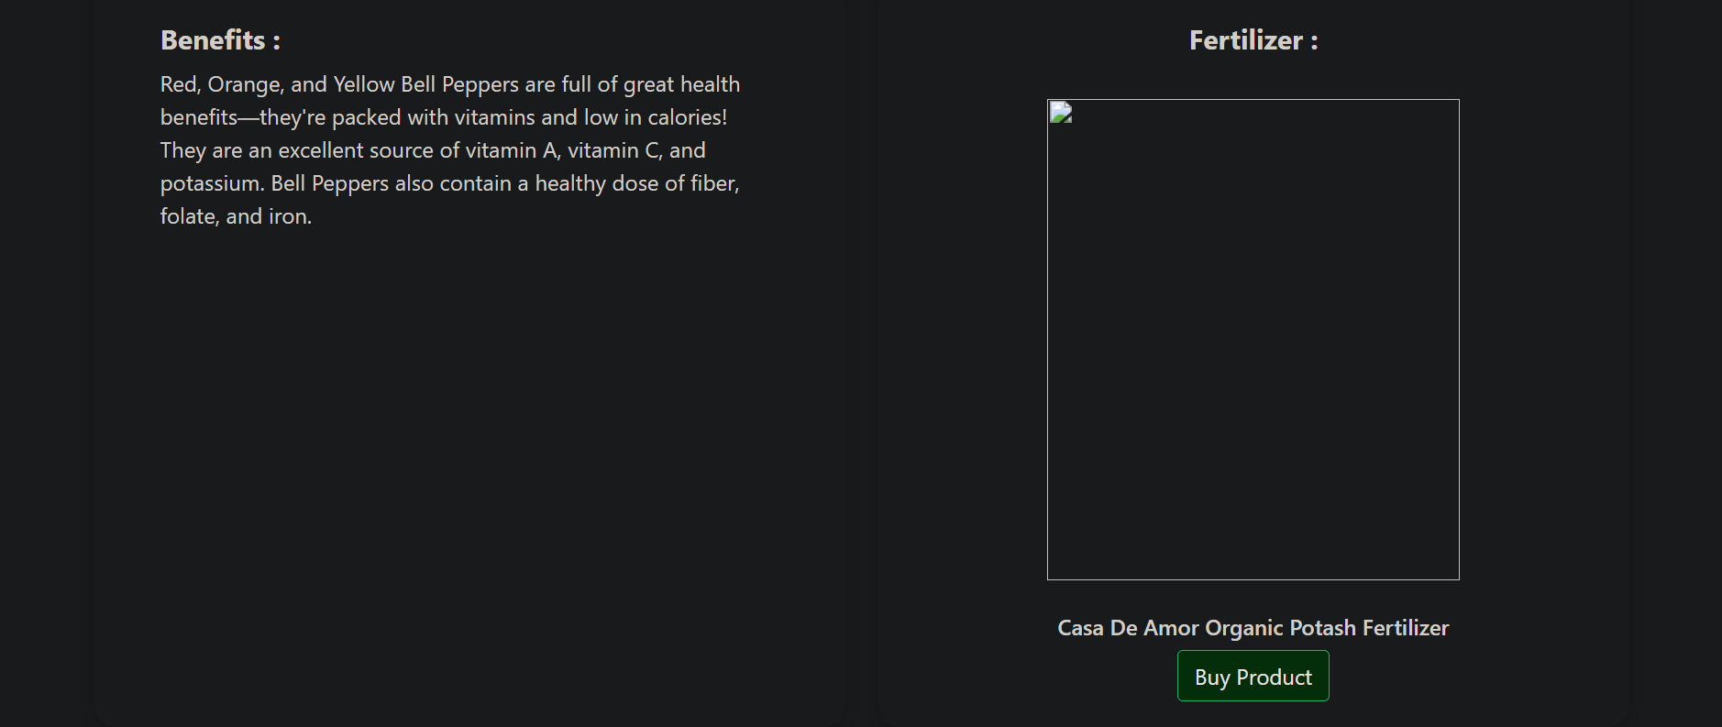

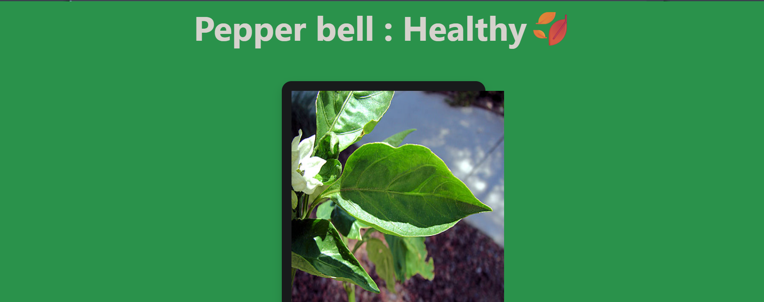

3.2 System Diagrams
Flow Chart
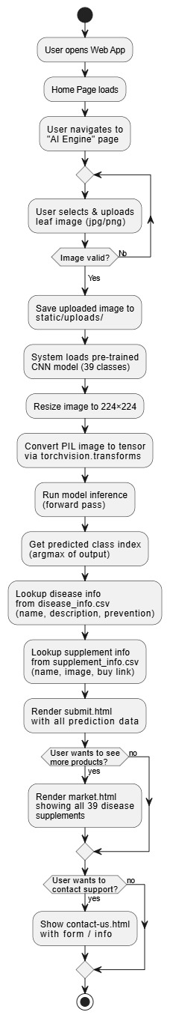
Use-Case Diagram
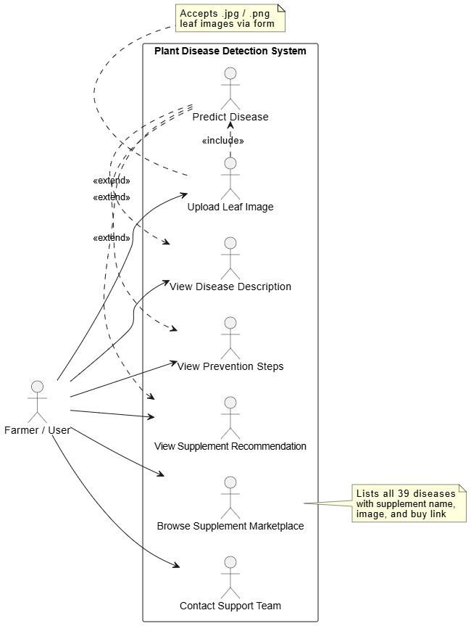

3.3 Postman API Testing
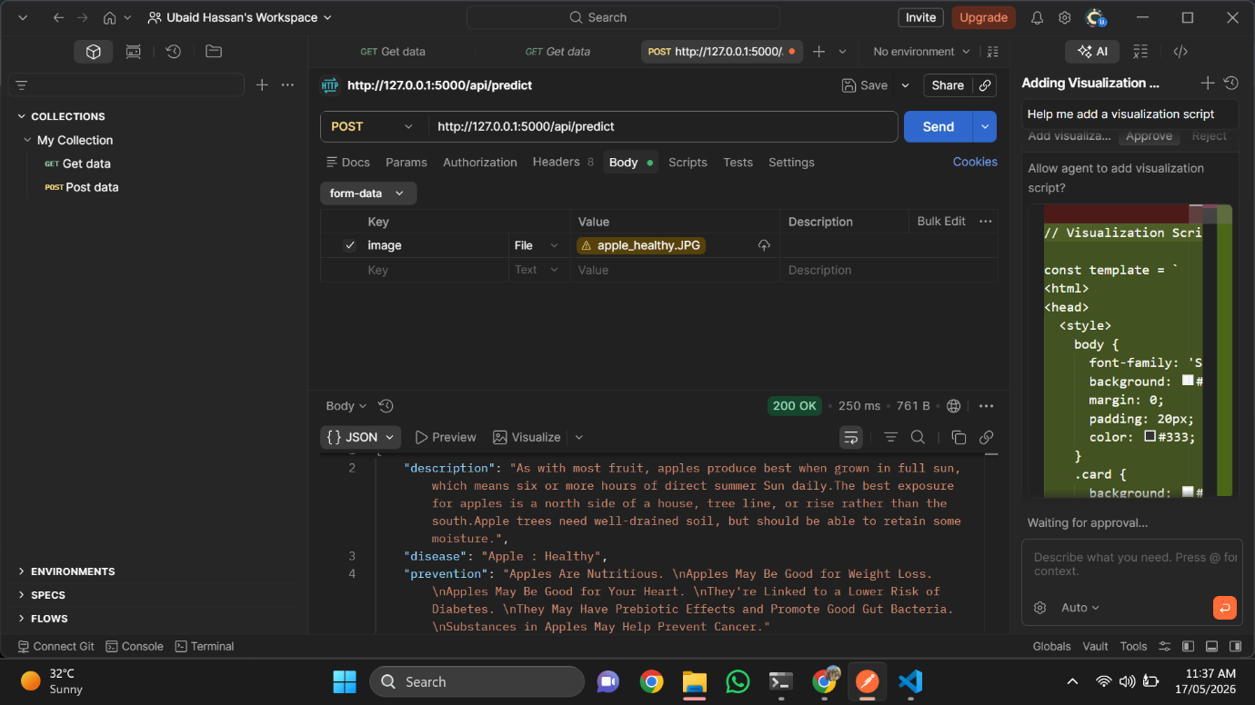
3.4 Unit Test Output
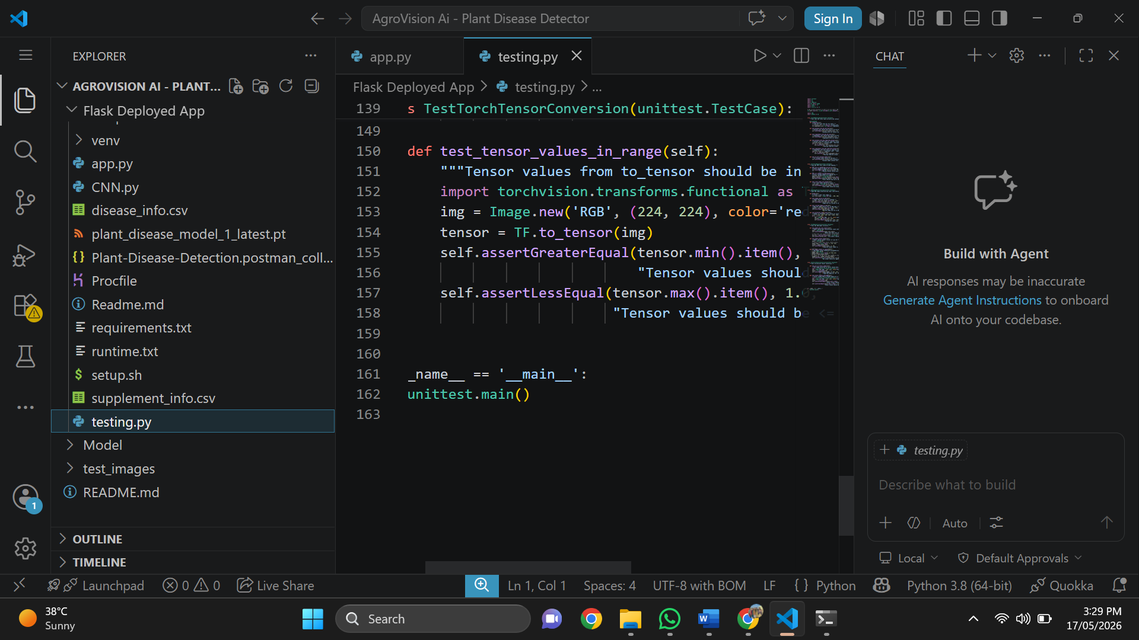
3.5 Trello Board
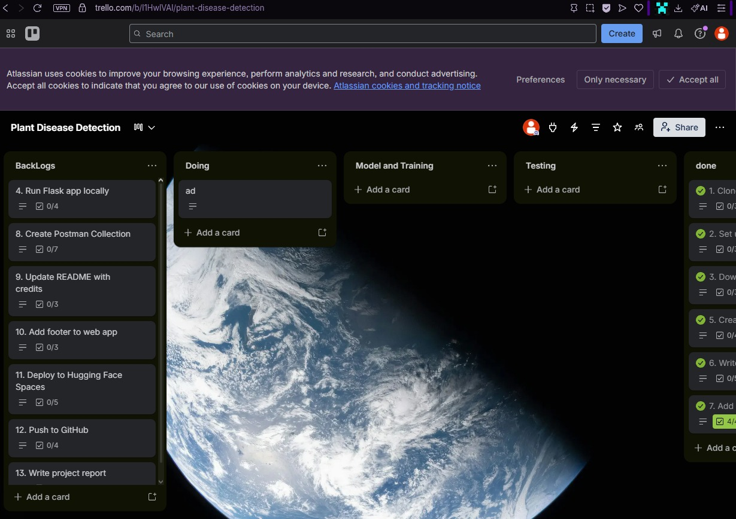
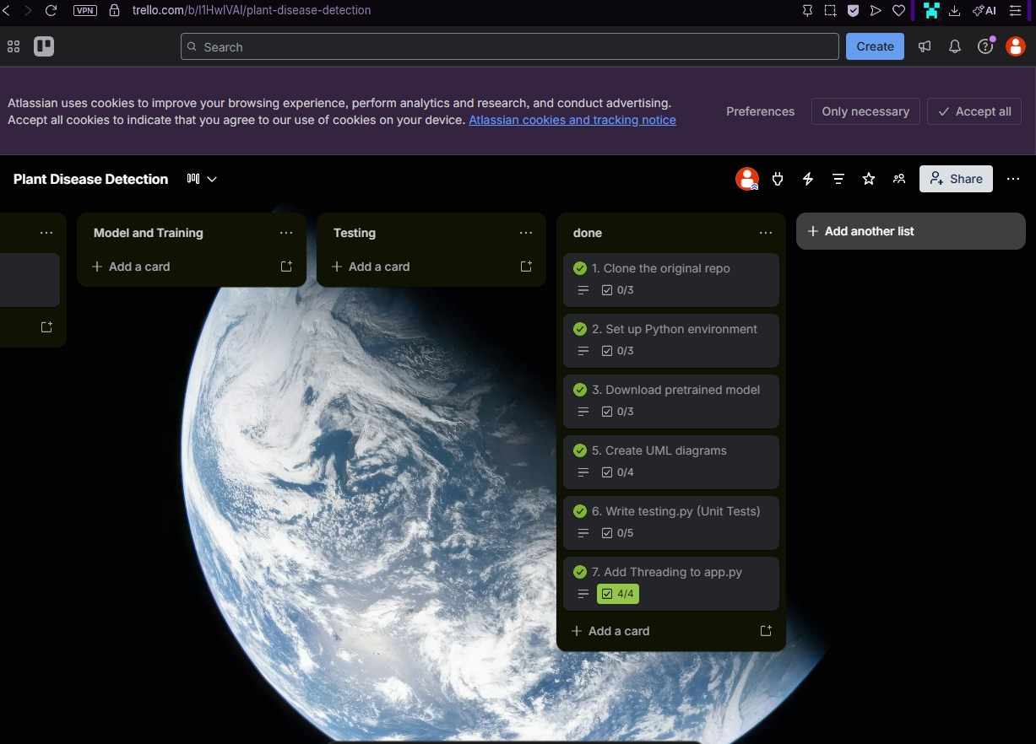
3.6 Threading Implementation
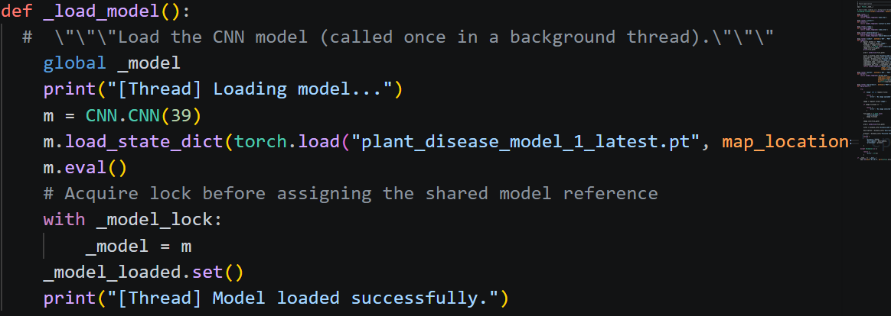
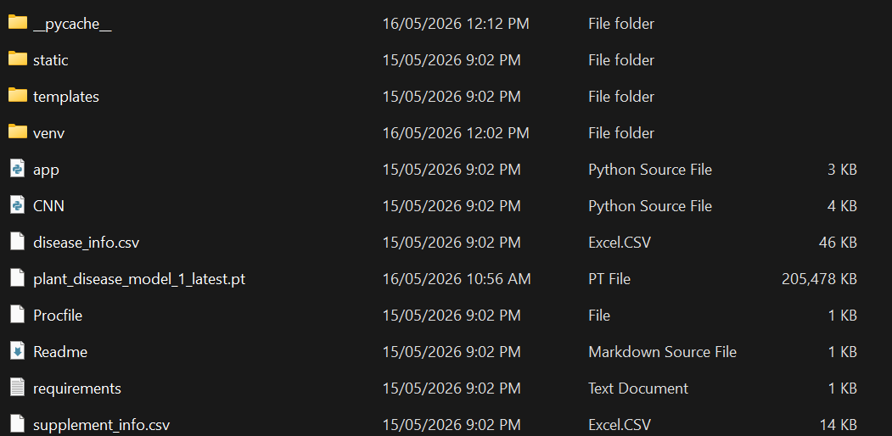

3.7 Additional Screenshots
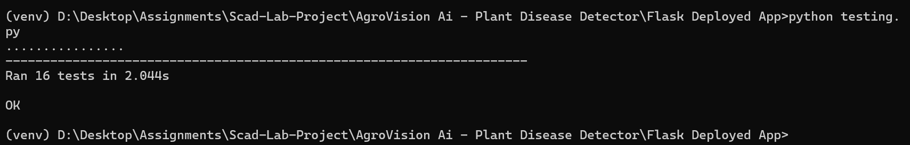
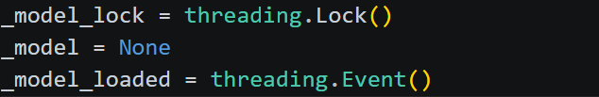
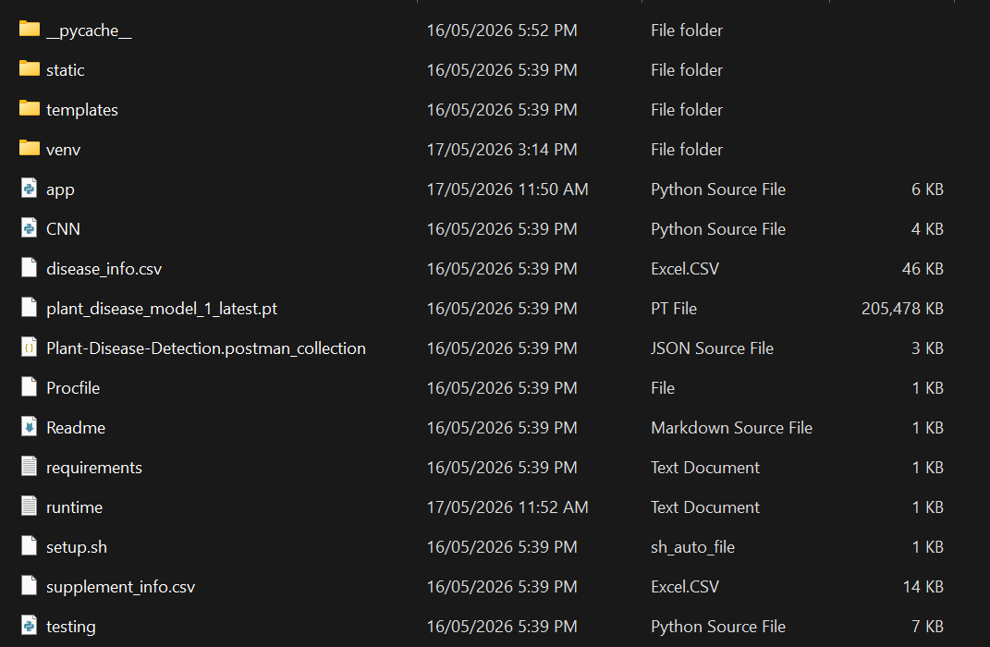
4. Limitations
- Dependence on Image Quality: The CNN model accuracy may decrease if the uploaded plant leaf image is blurry, captured in poor lighting, or contains background noise.
- Limited Disease Dataset: The model is trained on specific plant disease categories only. It may not correctly identify diseases outside the training dataset.
- CPU-Based Performance: Since the project runs without GPU support, prediction speed may be slower compared to GPU-based systems.
- Internet & Hosting Delays: When deployed on Hugging Face Spaces, the application may take time to start if the free server becomes inactive.
- Prediction Confidence Variations: Some diseases with very similar leaf patterns may produce less accurate predictions.

5. Future Work
- Mobile Application Integration: A cross-platform mobile app using React Native or Flutter for farmers to capture images from their phones.
- Real-Time Camera Detection: Live camera-based disease detection using continuous frame analysis.
- Expanded Disease Dataset: Train on more plant species and additional disease categories.
- Cloud Database Integration: Add MySQL or Firebase to store prediction history and user activity.
- Multilingual Support: Multi-language interface for farmers from different regions.
- Disease Treatment Recommendations: Pesticide suggestions, treatment methods, and fertilizer recommendations.
6. Changes We Made
6.1 Repository Comparison
Author’s Repository
GitHub: https://github.com/manthan89-py/Plant-Disease-Detection
Our Repository
GitHub: https://github.com/UbaidHassan2410/AgroVision_AI_Plant-Disease-Detector
Hugging Face: https://huggingface.co/spaces/UbaidHassan2410/Agrovision-Ai
6.2 Changes Overview
# | Change Description
1 | Developed a clean and responsive web interface using HTML, CSS, and Flask templates
2 | Implemented a Flask-based backend with routes for image upload, prediction, and /api/predict endpoint
3 | Integrated a CNN-based deep learning model trained on multiple plant disease categories
4 | Implemented Python threading, thread locks, and ThreadPoolExecutor for background model loading
5 | Created automated unit tests using Python's unittest framework
6 | Tested API endpoints using Postman for stable HTTP responses and JSON outputs
7 | Added error handling for missing files, invalid formats, runtime exceptions
8 | Combined frontend, backend, CNN model, and CSV disease info into a complete application
9 | Uploaded and maintained the project on GitHub with proper version control
10 | Deployed the application on Hugging Face Spaces for public access
6.3 Threading — Background Model Loading
# Start model loading in a background thread
threading.Thread(target=_load_model, daemon=True).start()
6.4 Threading — Thread-Safe Inference
_model_lock = threading.Lock()
def prediction(image_path):
def _infer(path):
model = get_model()
with _model_lock:
output = model(input_data)
return int(np.argmax(output))
with ThreadPoolExecutor(max_workers=1) as ex:
return ex.submit(_infer, image_path).result()
6.5 Unit Test Example
def test_model_output_shape(self):
"""Model should output a vector of size 39."""
model = CNN.CNN(39)
dummy_input = torch.randn(1, 3, 224, 224)
output = model(dummy_input)
self.assertEqual(output.shape, (1, 39))

7. References & Links
Original Project
- Author: Manthan Bhikadiya (manthan89-py)
- Repository: https://github.com/manthan89-py/Plant-Disease-Detection
- Blog: Plant Disease Detection Using CNNs with PyTorch (Medium)
Our Project
- GitHub: https://github.com/UbaidHassan2410/AgroVision_AI_Plant-Disease-Detector
- Hugging Face: https://huggingface.co/spaces/UbaidHassan2410/Agrovision-Ai
Tools & Libraries
Tool | Purpose
Python 3.8 | Primary programming language
PyTorch 1.8.1 | Deep learning framework (CNN model)
Flask 1.1.2 | Web framework (backend)
Pillow | Image processing
Pandas | CSV data handling
Postman | API testing
Trello | Project management
Hugging Face Spaces | Free hosting
Acknowledgement

— End of Report —

